**TWO COATS COLDER**

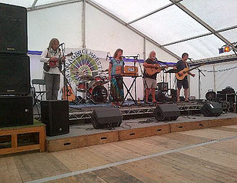From stage left : Chris - Ray - Anna - David

​

**Chris** 1Vox + 1DI + 1 240v power socket

**Ray** 1Vox + 1DI + 1 240v power socket

**Anna**  1Vox + 1Inst mic + 1 240v ps

**David** 1Vox + 1DI